## SIMATS SCHOOL OF ENGINEERING

**SAVEETHA INSTITUTE OF MEDICAL AND TECHNICAL SCIENCES**

**CHENNAI-602105**

UNIQUE BINARY SEARCH TREES

## A CAPSTONE PROJECT REPORT

*Submitted in the partial fulfillment for the award of the degree of*

# BACHELOR OF ENGINEERING

## IN

**COMPUTER SCIENCE & ENGINEERING**

## Submitted by

**K. Mahendra Reddy (192210413)**

**Under the Supervision of**

**Dr. Gnana Soundari**

# DECLARATION

We, **K. Mahendra Reddy** students of ‘**Bachelor of Engineering in Department of Computer Science’** in Saveetha Institute of Medical and Technical Sciences, Saveetha University, Chennai, hereby declare that the work presented in this Capstone Project Work entitled **"UNIQUE BINARY SEARCH TREES"** is the outcome of our own bonafide work. We affirm that it is correct to the best of my knowledge, and this work has been undertaken with due consideration of Engineering Ethics.

k. Mahendra Reddy 192210413

Date:

Place:Saveetha School of Engineering, Thandalam.

# CERTIFICATE

This is to certify that the project entitled **“UNIQUE BINARY SEARCH TREES”** submitted by **K. Mahendra Reddy**, has been carried out under our supervision. The project has been submitted as per the requirements in the current semester of B. Tech in Computer science & engineering .

Faculty-in-charge Dr. **Gnana Soundari**

**UNIQUE BINARY SEARCH TREES**

## PROBLEM STATEMENT:

Given an integer n, return the number of structurally unique BST's (binary search trees) which has exactly n nodes of unique values from 1 to n.

## ABSTRACT:

Determining the number of structurally unique Binary Search Trees (BSTs) that can be constructed with n distinct nodes, each with unique values ranging from 1 to n, is a significant problem in the realms of combinatorics and dynamic programming. This problem can be elegantly solved using the concept of Catalan numbers, which are integral to counting various combinatorial structures. By employing a dynamic programming approach, we can efficiently compute the number of unique BSTs by breaking down the problem into manageable subproblems and utilizing previously calculated results.

**KEYWORDS:** Structurally Unique, Binary Search Trees (BSTs), Distinct Nodes Unique Values, Combinatorics, Dynamic Programming, Catalan Numbers, Combinatorial Structures, Efficient Computation, Subproblems, Previously Calculated Results, Recursive Approach, Algorithm, Tree Construction, Enumeration.

## INTRODUCTION:

Binary Search Trees (BSTs) play a pivotal role in computer science, serving as a fundamental data structure that allows for efficient data organization and retrieval. Each BST is characterized by a unique property: for any given node, the values in the left subtree are smaller, and the values in the right subtree are larger. This hierarchical structure ensures that operations like search, insertion, and deletion can be performed swiftly, typically in logarithmic time. As a result, BSTs are integral to numerous applications, including database indexing and memory management, where fast access to data is crucial.

A particularly intriguing problem associated with BSTs is determining the number of different structural configurations that can be formed using n distinct nodes with values from 1 to n. This enumeration is not merely an academic exercise but has practical ramifications in optimizing data structures for various applications. By understanding the number of possible BST configurations, one can better appreciate the diversity and flexibility inherent in these structures, which in turn can inform more efficient algorithm design and implementation strategies in software development.

The solution to this problem employs dynamic programming and the Catalan numbers, a sequence of natural numbers that arise in various combinatorial contexts. Catalan numbers have profound applications beyond BSTs, appearing in problems related to parenthetical expressions, polygon triangulation, and more. By leveraging these numbers, one can systematically count the distinct BST configurations, thus providing valuable insights into the structural possibilities of BSTs. This approach not only highlights the elegance of mathematical techniques in solving complex problems but also underscores the deep connections between theoretical concepts and practical computing challenges.

## CODING:

To solve the problem, we use a dynamic programming approach where we define an array ‘dp’ such that ‘dp[i]’ holds the number of unique BSTs that can be constructed with i nodes. The base cases are straightforward: there is one unique BST with zero nodes (an empty tree) and one unique BST with one node. For n≥2, the number of unique BSTs can be computed by considering each node as the root and multiplying the number of unique left subtrees by the number of unique right subtrees for all possible root nodes. This dynamic programming solution is implemented as follows:

**C-programming:** #include <stdio.h> #include <stdlib.h>

// Definition for a binary tree node. struct TreeNode {

int val;

struct TreeNode* left; struct TreeNode* right;

};

// Function to create a new tree node struct TreeNode* createNode(int val) {

struct TreeNode* newNode = (struct TreeNode*)malloc(sizeof(struct TreeNode)); newNode->val = val;

newNode->left = NULL; newNode->right = NULL; return newNode;

}

// Function to clone a tree

struct TreeNode* cloneTree(struct TreeNode* root) { if (!root) return NULL;

struct TreeNode* newNode = createNode(root->val); newNode->left = cloneTree(root->left);

newNode->right = cloneTree(root->right); return newNode;

}

// Function to generate all unique BSTs for values from start to end

struct TreeNode** generateTreesHelper(int start, int end, int* returnSize) { if (start > end) {

struct TreeNode** base = (struct TreeNode**)malloc(sizeof(struct TreeNode*)); base[0] = NULL;

*returnSize = 1; return base;

}

int totalSize = 0;

struct TreeNode** allTrees = (struct TreeNode**)malloc(10000 * sizeof(struct TreeNode*)); // Adjust size as needed

for (int i = start; i <= end; i++) { int leftSize, rightSize;

struct TreeNode** leftTrees = generateTreesHelper(start, i - 1, &leftSize);

struct TreeNode** rightTrees = generateTreesHelper(i + 1, end, &rightSize);

for (int l = 0; l < leftSize; l++) {

for (int r = 0; r < rightSize; r++) {

struct TreeNode* root = createNode(i); root->left = cloneTree(leftTrees[l]); root->right = cloneTree(rightTrees[r]); allTrees[totalSize++] = root;

}

}

free(leftTrees); free(rightTrees);

}

*returnSize = totalSize; return allTrees;

}

// Function to generate all unique BSTs for values 1 to n struct TreeNode** generateTrees(int n, int* returnSize) {

if (n == 0) {

*returnSize = 0; return NULL;

}

return generateTreesHelper(1, n, returnSize);

}

// Helper function to print a tree structure

void printTree(struct TreeNode* root, int space, int level) { if (!root) return;

// Increase distance between levels space += level;

// Print right child first printTree(root->right, space, level);

// Print current node after space printf("\n");

for (int i = level; i < space; i++) { printf(" ");

}

printf("%d\n", root->val);

// Print left child

printTree(root->left, space, level);

}

// Function to print all unique BSTs

void printAllTrees(struct TreeNode** trees, int size) { for (int i = 0; i < size; i++) {

printf("Tree %d:\n", i + 1); printTree(trees[i], 0, 10); printf("\n");

}

}

// Function to free the memory of a tree void freeTree(struct TreeNode* root) {

if (!root) return; freeTree(root->left); freeTree(root->right); free(root);

}

// Function to free the memory of all trees

void freeAllTrees(struct TreeNode** trees, int size) { for (int i = 0; i < size; i++) {

freeTree(trees[i]);

}

free(trees);

}

int main() { int n;

printf("Enter the number of nodes: ");

scanf("%d", &n);

int returnSize;

struct TreeNode** trees = generateTrees(n, &returnSize);

printf("All unique BSTs with %d nodes are:\n", n); printAllTrees(trees, returnSize);

// Print the number of unique BSTs

printf("Number of unique BSTs with %d nodes: %d\n", n, returnSize);

// Free allocated memory freeAllTrees(trees, returnSize);

return 0;

}

## OUTPUT:

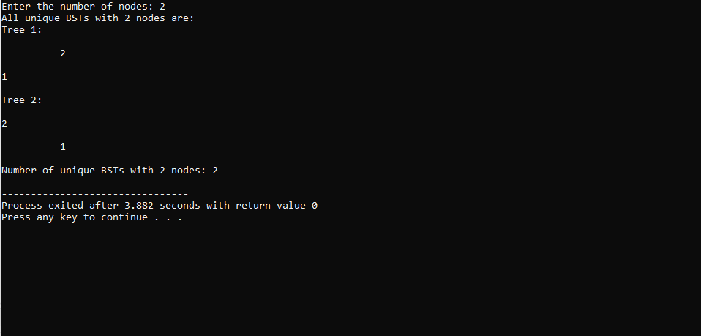

**COMPLEXITY ANALYSIS:**

**Time Complexity**: The algorithm has a time complexity of O(n^2). This arises because for each node count from 2 to n, the algorithm considers each node as a potential root and calculates the number of unique left and right subtrees, leading to a nested loop structure. Hence, for each i from 2 to n, an inner loop runs iii times, resulting in a quadratic time complexity.

**Space Complexity**: The space complexity is O(n) due to the dynamic programming array ‘dp’ that stores the number of unique BSTs for each count of nodes from 0 to n. This array is necessary to store intermediate results and avoid redundant calculations, making the solution efficient in terms of both time and space.

## BEST CASE:

The best-case scenario occurs when n is very small, such as n=0 or n=1. In these cases, the function quickly returns results 1 and 1, respectively, as there is only one way to arrange 0 or 1 nodes into a BST. The minimal computational overhead in these cases leads to immediate

results, showcasing the simplicity and efficiency of the base cases in the dynamic programming solution.

## WORST CASE:

The worst-case scenario is when n is large, as the algorithm must perform O(n^2)operations to compute the number of unique BSTs. For large values of n, the algorithm fully exercises the nested loop structure, iterating through all possible root nodes for each subtree configuration. This results in significant computational effort, demonstrating the quadratic growth in complexity relative to the size of the input.

## AVERAGE CASE:

For average values of n, the time complexity remains O(n^2). The average case does not differ significantly from the worst case because the algorithm must consider every possible subtree configuration for each node count up to n. The dynamic programming approach ensures that intermediate results are reused, maintaining a consistent and efficient solution across different input sizes, but the overall complexity still scales quadratically.

## CONCLUSION:

The problem of finding the number of structurally unique BSTs that can be formed with n distinct nodes is effectively addressed using dynamic programming. By recognizing that the number of unique BSTs for a given n can be derived from the unique BSTs of smaller subproblems, we can construct a solution that leverages Catalan numbers. This approach, with a time complexity of O(n^2) and space complexity of O(n), provides an efficient and robust method for solving this combinatorial problem. The dynamic programming solution highlights the importance of breaking down complex problems into simpler subproblems and reusing intermediate results, a common strategy in algorithm design.